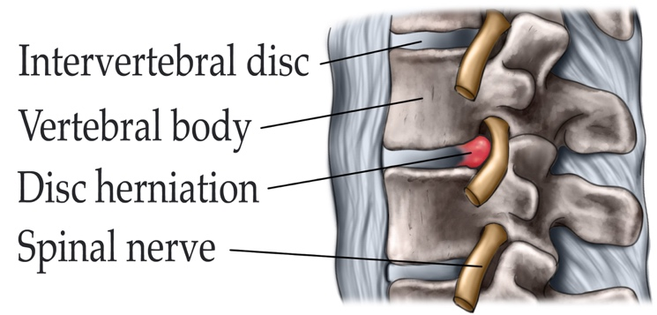
ENDOSCOPIC LUMBAR DISCECTOMY
What is a lumbar disc herniation? Intervertebral discs function as shock absorbers between vertebral bodies. Intervertebral discs have an inner gel-like center (nucleus) which is surrounded by an outer fibrous disc wall (anulus fibrosus). Different terms are utilized to describe disc herniations. A true disc herniation (also called a ruptured or slipped disc) occurs when the nucleus of the disc ruptures throught a tear in the fibrous disc wall. The extruded disc material then impinges your nerve root and causes a chemical irritation. If the bulging disc remains within the disc wall and forms an outpouching pressing against the nerves is referred to as a disc protrusion.
What are the Symptoms:
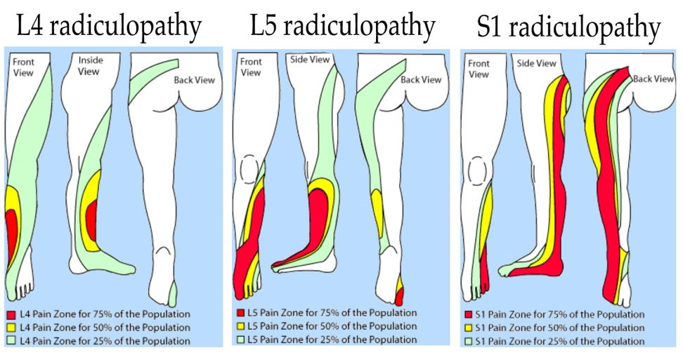
Symptoms of a herniated disc depend greatly on the location of the herniation and your own response to pain. If you have suffered from a lumbar disc herniation, you may feel pain that radiates from your low back area, down one or both legs, and sometimes into your feet (called sciatica). You may feel a pain like an electric shock that is severe whether you stand, walk, or sit. Activity such as bending, lifting, twisting, or sitting may increase the pain. Lying flat on your back with knees bent may be the most comfortable as it relieves the pressure onto the nerve root. Sometimes the pain is accompanied by numbness and tingling in your leg or foot. You may experience cramping or muscle spasms in your back or leg. In addition to pain, you may have leg muscle weakness, or knee or ankle reflex loss. In severe cases, you may experience foot drop (your foot flops when you walk) or loss of bladder or bowel control. If you experience extreme leg weakness or difficulty controlling bladder or bowel function, you should seek medical help immediately.
What are the Causes:
Discs herniations may occur spontaneously or can be caused by injury or improper lifting. Aging plays an important role. As you get older, your discs dry out and become harder. The tough fibrous disc wall of the disc may weaken. The gel-like nucleus may bulge or rupture through a tear in the disc wall, causing pain when it touches a nerve. Genetics, smoking, and a number of occupational and recreational activities may lead to early disc degeneration.

Who is affected:
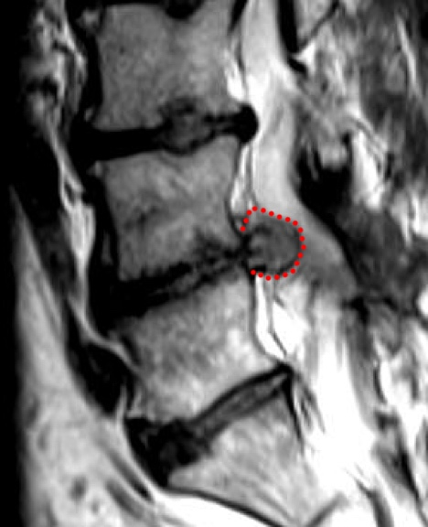
Herniated discs occur most commonly in people in their 30s and 40s, although older people are slightly more at risk if they're involved in strenuous physical activity. Lumbar disc herniations are one of the most common causes of low back pain in combination with leg pain, and occurs 15 times more frequently than cervical (neck) disc herniation. Disc herniations occur 8% of the time in the cervical (neck) region and only 2% of the time in the upper-to-mid-back (thoracic) region.

How the diagnosis is made:
Your physician is taking a history of your symptoms and performs a physical exam in order to determine the source of the pain and tests for any muscle weakness or numbness. If the findings are consistent with the diagnosis of a lumbar disc herniation a lumbar magnetic resonance imaging (MRI) study is obtained. This noninvasive test uses a magnetic field and radiofrequency waves to give a detailed view of the soft tissues of your spine. Unlike an X-ray, nerves and discs are clearly visible. This imaging study can detect which disc is damaged and if there is any nerve compression. It can also detect bony overgrowth, spinal cord tumors, or abscesses. In certain circumstances your doctor may order additional studies such as: X-rays, CT scan, or EMG.
What treatments are available:
Unless you have a severe motor weakness or problems with your bladder function, conservative non-surgical treatment is the first step to recovery. Medication, rest, physical therapy, home exercises, hydrotherapy, epidural steroid injections (ESI), chiropractic manipulation, and pain management will result in significant improvement in 80% of people in about 6 weeks and return to normal activity. If you don’t respond to conservative treatment, your doctor may recommend surgery.

Medications: Your doctor may prescribe nonsteroidal anti-inflammatory medications (NSAIDs), pain relievers, muscle relaxants, or steroids.
- Nonsteroidal anti-inflammatory drugs (NSAIDs), such as aspirin, naproxen (Alleve, Naproxen), ibuprofen (Motrin, Nuprin, Advil), or celecoxib (Celebrex), may be used to reduce inflammation and relieve pain. Long-term use of NSAIDs may cause stomach ulcers as well as kidney and liver problems.
- Analgesics, such as acetaminophen (Tylenol), can relieve pain but don’t have the anti-inflammatory effects of NSAIDs.
- Muscle relaxants, such as methocarbamol (Robaxin), carisoprodol (Soma) and cyclobenzaprine (Flexeril), may be prescribed to control muscle spasms.
- Steroids may be prescribed to reduce the swelling and inflammation of the nerves. They are taken orally (as a Medrol dose pack) in a tapering dosage over a five-day period. It has the advantage of providing almost immediate pain relief within a 24-hour period.
- For severe pain, Opioids such as Tramadol, hydrocodone (Norco, Vicodin) or oxycodone (OxyContin, Percocet) can be considered. However, these medications should only be taken under careful supervision of a physician given their adverse effects and the potential to lead to addiction.
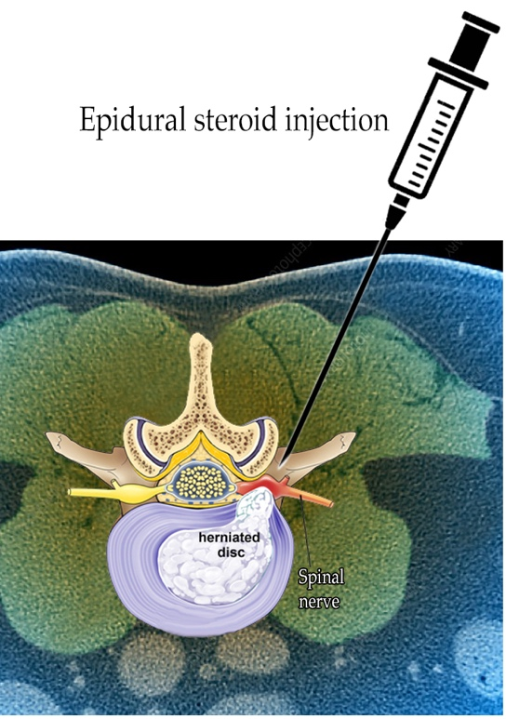
Epidural steroid injections: The procedure is performed under x-ray fluoroscopy and involves an injection of corticosteroids and a numbing agent into the epidural space of the spine. The medicine is delivered next to the painful area to reduce the swelling and inflammation of the irritated nerve. About 50% of patients will notice relief after an epidural injection, although the results tend to be temporary. Repeat injections may be given to achieve the full effect. Duration of pain relief varies, lasting for weeks or years. Injections are done in conjunction with a physical therapy and/or home exercise program.
Physical therapy: The goal of physical therapy is to help you return to full activity as soon as possible and prevent re-injury. Physical therapists can instruct you on proper posture, lifting, and walking techniques, and they will help you to strengthen your lower back, leg, and stomach muscles. They’ll also encourage you to stretch and increase the flexibility of your spine and legs. Exercise and strengthening exercises are key elements to your treatment and should become part of your life-long fitness.
Alternative therapies: Some patients find acupuncture, trigger point injection, acupressure, nutrition / diet changes, meditation, and biofeedback helpful in managing pain as well as improving overall health.
What surgical treatments are available:
Surgery for a herniated lumbar disc, a procedure referred to as discectomy, may be an option if your symptoms do not respond to conservative treatments. Surgery may also be recommended if you have signs of nerve damage, such as weakness or loss of feeling in your legs or problems with your bladder function.
Microsurgical discectomy: The surgeon makes a 1–2 inch incision in the middle of your back. To reach the damaged disc, the spinal muscles are dissected and moved aside to expose the vertebra. A portion of the bone is removed to expose the nerve root and the herniated disc. The portion of the ruptured disc that touches your spinal nerve is carefully removed using special instruments. About 80–85% of patients successfully recover from a discectomy and are able to return to their normal job in approximately 6 weeks.
Minimally invasive discectomy: The surgeon makes a small incision in the back. Small tubes called dilators are used with increasing diameter to gently retract the spinal muscles and to create a tunnel to the vertebra. A portion of the bone is removed to expose the nerve root and disc herniation. The surgeon uses a microscope and microsurgical tools to remove the ruptured disc. This technique causes less muscle injury than a traditional discectomy.

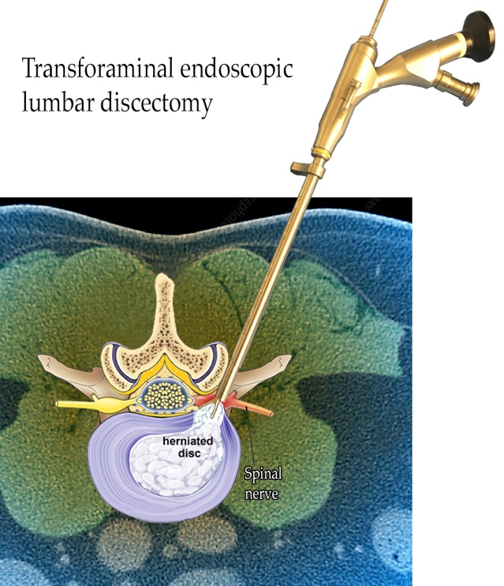
Full-endoscopic discectomy: The surgery will involve a general anesthetic so that you are asleep throughout the procedure. The surgeon makes stab incision in the back. Small tubes called dilators, the diameter of a pen, are used to create a tunnel to the vertebra. An endoscope is then advanced to the site of the disc rupture which allows for superior visualization of the disc herniation and the neural elements. Given the small size of the endoscope often no or only a minimal amount of bone is removed to gain access to the herniated disc fragment. Specialized tools are brought in via the endoscope towards the disc herniation and disc material impinging the nerve root is removed. Once the surgery is complete, the anesthetic is reversed. The skin around the incision is injected with long-acting numbing medication and you are taken to the recovery room.
Why do we perform full-endoscopic discectomies?
Three randomized controlled trials (the highest quality data in medicine) have shown that full-endoscopic provides similar or better functional results compared to minimally invasive technique while reducing the local and systemic tissue trauma, the length of hospital stay and the rate of complications {Ruetten, 2008 #63; Gibson, 2017 #64; Chen, 2018 #65}. The transition from microsurgical to minimally invasive to full-endoscopic discectomy has dramatically decreased the invasiveness of procedures. Less invasiveness means fewer complications in spine surgery {Lee, 2012 #12}. We have shown that the rate of adverse events with full-endoscopic spine surgery is approximately 2.7% {Sen, 2018 #153}. Adverse events include re-herniations, dural tears, hematomas and medical complications.
Your hospital stay:
Despite the small stab wound (< ¼ inch) and the use of local numbing medication and pain medication with your anesthesia, you may wake up with minimal to moderate pain at the site of surgery. Typically, the discomfort is well controlled with oral anti-inflammatory medications that you receive in the recovery room and that you can continue to take at home. In most cases, you will be up and walking a few hours after the operation. You must be able to eat, drink and go to the bathroom to void urine prior to discharge. Most patients return home on the same day just hours after the surgery. Elderly patients (older than 70 years) or patients with complicated medical conditions may stay to recover overnight in the hospital.
Signs and symptoms of healing in the post-operative period
- The pain around your incision typically remains stable for the first 3-4 days and then slowly improves
- The character of your leg pain typically changes immediately after surgery. There is a wide variety of nerve symptoms during recovery depending on what particular part of the nerve was impinged and how severe the nerve was damaged. Many patients describe a sensation of mild tingling and burning in the leg area that was the site of shooting pain before surgery. Often there is also decreased sensation or numbness in this area. During the recovery leg muscles may be sore in response to only moderate physical activity. These sensations may be experienced in the first 3 – 6 weeks after surgery. In some patients, depending on the degree of chronic nerve damage, an area of numbness may remain.
- Weakness in your leg may take weeks and months to improve. In some cases no or incomplete recovery is achieved depending on the degree of chronic nerve damage.
- Recovery of bladder function is variable
Intraoperative view during a transforaminal endoscopic lumbar discectomy
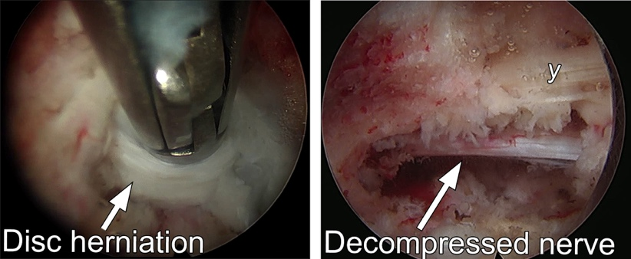
Recommendation for your optimal recovery:
- Surgical incision: The incision will be closed with dissolving stiches and reinforced with sticky strips. The incision must stay covered for 24 hours and then may be left open to the air. You should not scrub or submerge your incision until 2 weeks after surgery to allow time to heal. Patients with diabetes, those taking steroids for other conditions, and those whose immune system may be compromised often need additional time for their wounds to completely heal. If there is any redness, tenderness, swelling or discharge from the wound you should see your family doctor or call our clinic immediately.
- We recommend to avoid strenuous physical activity during the first 3 weeks after surgery. However, we recommend that you should continue regular gentle exercise such as walking.
- Heavy lifting (more than 15 lbs) and bending as well as twisting of your torso should be avoided during the first 3 months after surgery in order to minimize the risk of re-herniation.
- Resume any blood thinning medications which have been stopped for surgery needs to be discussed on an individual basis in order to weigh the benefits against the risks.
- You may need to make plans to be off 1-6 weeks depending on the work you do. Heavy lifting should not be performed during the first 3 months after surgery. You may drive as long as you are not taking narcotic pain pills.
Follow-up:
You will need to be seen again by your neurosurgeon 2 weeks after surgery to make sure your wound is healing well, and then 3 months after surgery to confirm successful recovery. We will also reach out to you via phone, mail or electronically 1 and 2 years after surgery to confirm that your recovery was optimal and that there no other issues that need to be addressed.
Recommendations for healthy living:
Back pain affects 8 of 10 people at some time in their lives, and usually resolves within 6 weeks. A positive mental attitude, regular activity, and a prompt return to work are all very important elements of recovery. If your regular job cannot be done initially, it is in your best interest to return to some kind of modified (light or restricted) duty. Our office can give prescriptions for such activity for limited periods of time.
The key to avoiding recurrence is prevention:
- Proper lifting techniques
- Good posture during sitting, standing, moving, and sleeping
- Appropriate regular exercise to strengthen weak abdominal muscles and prevent re-injury
- An ergonomic work area
- Healthy weight and lean body mass
- A positive attitude and stress management
- No smoking
Sources & links:
If you have more questions, please contact the University of Washington complex spine center:
Links:
www.spine-health.com
www.spineuniverse.com

Glossary:
annulus (annulus fibrosis): tough fibrous outer wall of an intervertebral disc.
disc (intervertebral disc): a fibrocartilagenous cushion that separates spinal vertebrae. Has two parts, a soft gel-like center called the nucleus and a tough fibrous outer wall called the annulus.
foramen (intervertebral foramen): the opening or window between the vertebrae through which the nerve roots leave the spinal canal.
nucleus (nucleus pulposus): soft gel-like center of an intervertebral disc.
sciatica: pain that courses along the sciatic nerve in the buttocks and down the legs. Usually caused by compression of the fifth lumbar spinal nerve.
vertebra: (plural vertebrae): one of 33 bones that form the spinal column, they are divided into 7 cervical, 12 thoracic, 5 lumbar, 5 sacral, and 4 coccygeal. Only the top 24 bones are moveable.

